Cambridge City Foodbank partners with Citizens Advice Bureau to help eradicate food poverty in Cambridge

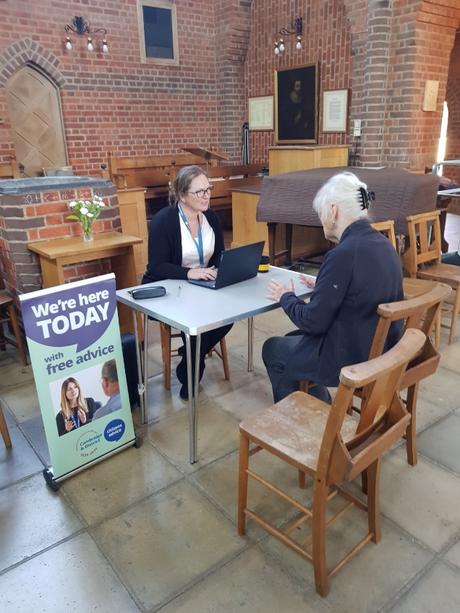

Cambridge City Foodbank has announced a new partnership with the Cambridge & District Citizens Advice Bureau, which will provide Foodbank visitors with access to free financial advice. Sessions will be held in the Foodbank distribution centres and will be accessible exclusively to Foodbank visitors.

All of the eight Foodbank distribution centres and two Fairbite social supermarkets across Cambridge will have an advisor from the Citizens Advice Bureau present at a session once every two weeks. The advisors, who are specially trained to provide individuals access to fuel, housing and other benefits, will also share financial advice to help maximise visitors’ financial situations and move away from food poverty.

Building partnerships with external agencies forms a key part of the Foodbank’s long-term strategy for eradicating food poverty in Cambridge. To date, the Foodbank has partnered with over 140 different referral and support agencies, including: Wintercomfort, Cambridge Community Foundation and Child and Family Centres.

Steve Clay, CEO of Cambridge City Foodbank, said: “I am pleased to announce our new partnership with the Citizens Advice Bureau. Those in need of emergency food support are often weighed down with financial burdens, and I hope that by providing expert advice on this particular, complex piece of the poverty puzzle, we are able to support them on their journeys to becoming financially stable. Thank you to everyone at the Citizens Advice Bureau who has helped to facilitate this partnership to date.

“2023 has seen us experience record levels of demand for emergency food support, which has seen the Foodbank distribute significantly more food than we have received in donations on a monthly basis. This is not sustainable long-term, however it is our hope that through building further partnerships with external agencies, and increasing our levels of wrap-around support, we will be able to move people away from relying on foodbanks. Emergency food support will always be available for those who need it, but ultimately, we want to see the end of long-term reliance on foodbanks in Cambridge. We believe that partnerships are the key to making this a reality.”

Rachel Talbot, Chief Executive of Cambridge & District Citizens Advice Bureau, said: “This is a great project providing more help to people in their communities - where and when they need it. At Cambridge Citizens Advice we have an aim to be based in more local settings and the Foodbank Charity could not be better placed to be at the heart of this. Happily, with the funding from this project our advisers are there and waiting to help - no question too small or too large.”

To find out more about Cambridge City Foodbank, visit: https://cambridgecity.foodbank.org.uk/

ENDS

Photo caption: A Cambridge & District Citizens Advice Bureau advisor at a Foodbank distribution centre

For further information and high-res images please contact Tom Evans on 01223 421 831 or email tom.evans@consciouscomms.com

About Cambridge City Foodbank

The Cambridge City Foodbank is part of a nationwide network of foodbanks, affiliated to The Trussell Trust, working to promote food justice and eradicate food poverty and hunger across the UK. The Cambridge City Foodbank was founded in 2010 by local churches and community groups looking to address the issues of food poverty in the city. The Cambridge City Foodbank has a range of sites across Cambridge where visitors, who are referred to its services in crisis, can access emergency support and food. As a well-established charity, it is instrumental in the development of long-term and sustainable strategies for addressing food justice issues in Cambridge by providing nutritionally-balanced emergency food and support to local people. Cambridge City Foodbank also runs a fuel support scheme that aims to address fuel poverty.

